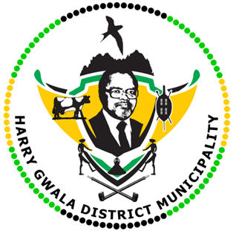
HARRY GWALA DISTRICT MUNICIPALITY
“Together We Deliver and Grow”
OFFICE OF THE MUNICIPAL MANAGER
40 Main Street, Private Bag X501, IXOPO 3276
Tel: (039) 834 8707 Fax: (039) 834 1701
Email: NgubaneN1@harrygwaladm.gov.za

17 JULY 2023

Harry Gwala District performs at the Dundee July.
The Harry Gwala District took part in the 2023 Dundee July over the weekend and performed well. The 2023 Dundee July exceeded expectations in all three main aspects of horseracing, fashion, and entertainment. The glamorous event organized by the KZN Department of Sport, Arts, and Culture in collaboration with local Municipalities, KZN Traditional Horse Racing and Breeding Association, and various stakeholders, was held over the weekend in Dundee racecourse.
Since the entire Dundee July is centered around rural horseracing, the jockeys, and their well-trained horses were raring to go from the morning. 12 races were staged, and the main race was won by Lindani Dube from Mpumalanga province who rode his horse, Alpha, and Omega to victory.
Jockey from the Harry Gwala District, Khanyisa Mbhele with his horse Eliya won race 7, and jockey Sivuyile Kabele came in position four in the same race with his horse Chitha. Mkhuliseli Mncuza with his horse Zahlangana came out second on Race 10.
Other horses that took part at the Dundee from the district included: Slingo, Ndlondlo, Vulakuvaliwe, Gqokelaphandle, and Laptop to name a few.
Leadership, managers, and officials from the district in support of the jockeys and rural horse racing attended the Dundee in July.
The district towards the end of the year will host the Summer Cup, which is a similar event.
The Harry Gwala District Mayor Cllr. Zamo Nxumalo, congratulated the horses who represented the district well at the Dundee July.
The MEC for DSAC, Dr Ntuthuko Mahlaba, expressed excitement at the successful holding of 2023 Dundee July saying it has been one of the best.
"The growth of this event augers well for our sports tourism objectives. These are the kinds of economic boosts that small towns like Dundee need.
"I am pleased that this is an initiative started by our own people and can only grow in stature through proper and coordinated support from the government and the private sector," said Mahlaba.
After all the races, fashion parades, and entertainment during the day, the 2023 extravaganza of the Dundee July was concluded with an entertainment event whose MC was Tha Simelane aka Nontakubukwa. Locals braced for the overnight cold weather and partied until the wee hours of Sunday.
ISSUED BY HARRY GWALA DISTRICT MUNICIPALITY COMMUNICATIONS UNIT.
0398348707

